**Run Book**

This aim of this document is to provide the detailed steps to run the backend and front-end system.

This includes the steps as mentioned below.

Repository location:

* https://github.com/suniltiwari778/VehicleRegoApp.git

# Steps

* clone the code from repository using command –

**git clone** <https://github.com/suniltiwari778/VehicleRegoApp.git>

or download the zip project folder and extract on your pc.

* Then, first start the backend code as mentioned in Back_end section.
* Then start the frontend code as mentioned in fron_end section.

# Back_End:

1. Open the command prompt.
2. Locate the directory [VehicleRego-Backend](https://github.com/suniltiwari778/VehicleRegoApp/tree/master/VehicleRego-Backend).
3. Go inside target directory using command: cd target
4. Run the command: java -jar assignment-0.0.1-SNAPSHOT.jar
5. It will start the backend code on port 8088.
6. Once the backend starts successfully run the front-end code.

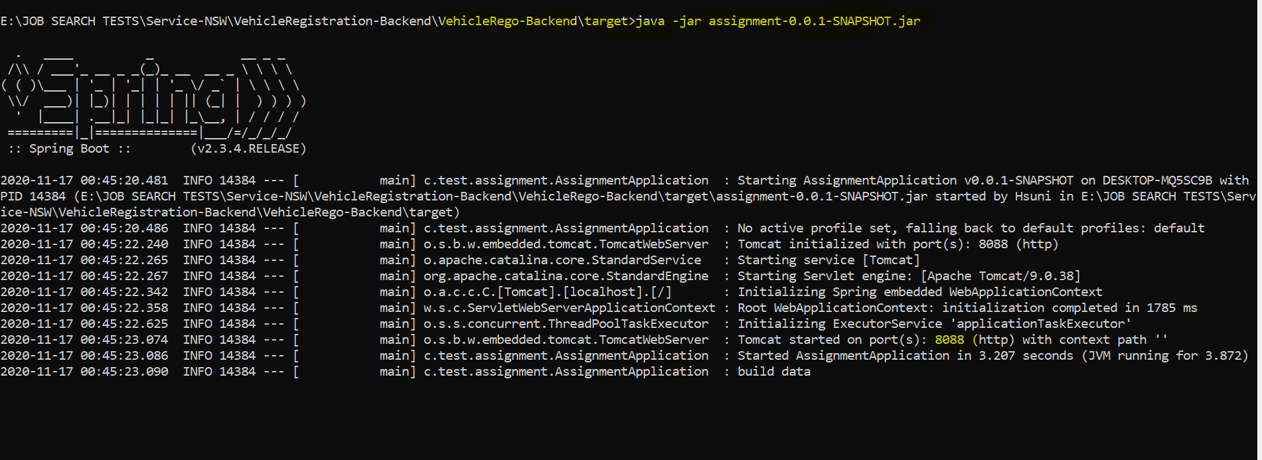

# Front-End

Steps to start front-end code-

1. Open the command prompt.
2. Locate the directory VehicleRego-Front-End.
3. Run the command: npm start

1. It will run on port 3000 as below

* Screen 1

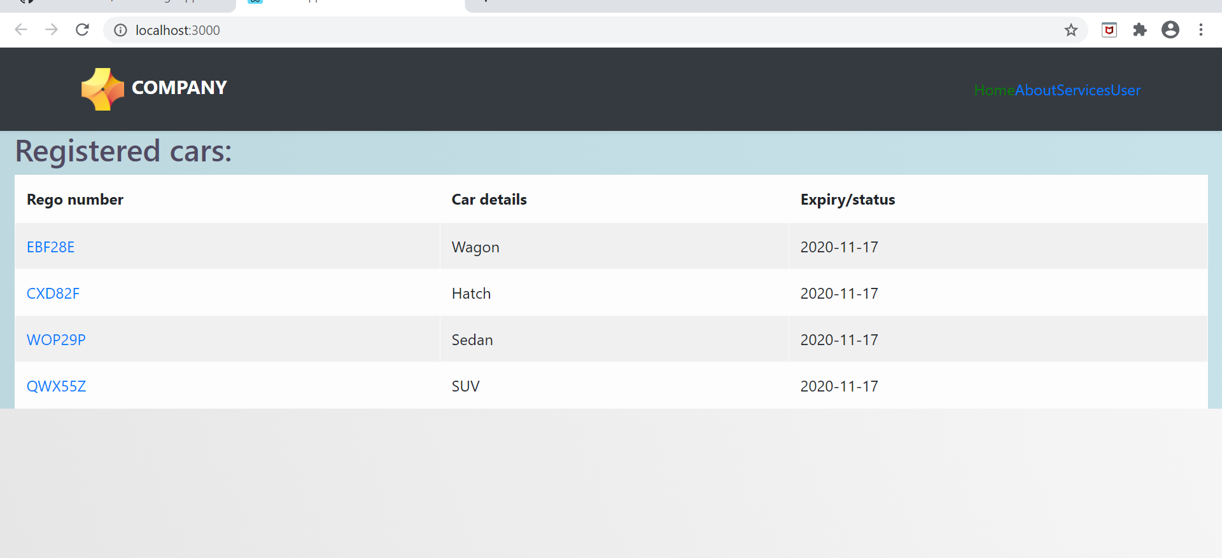

* Screen 2

After clicking on Rego number

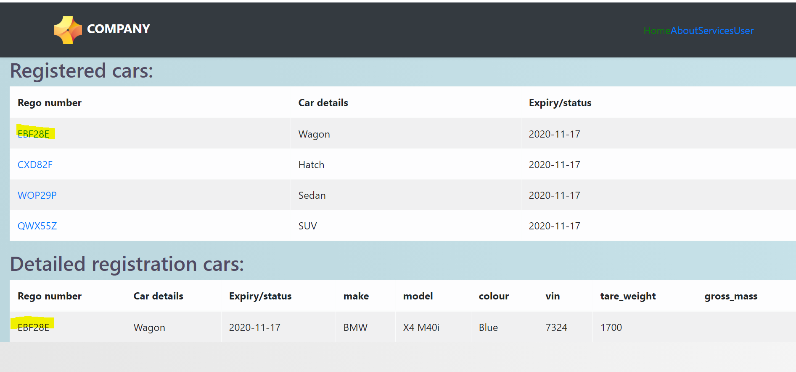

* Screen 3 – Stop the backend (ctl+C) to test this functionality

When there is a network issue:

Backend stpped: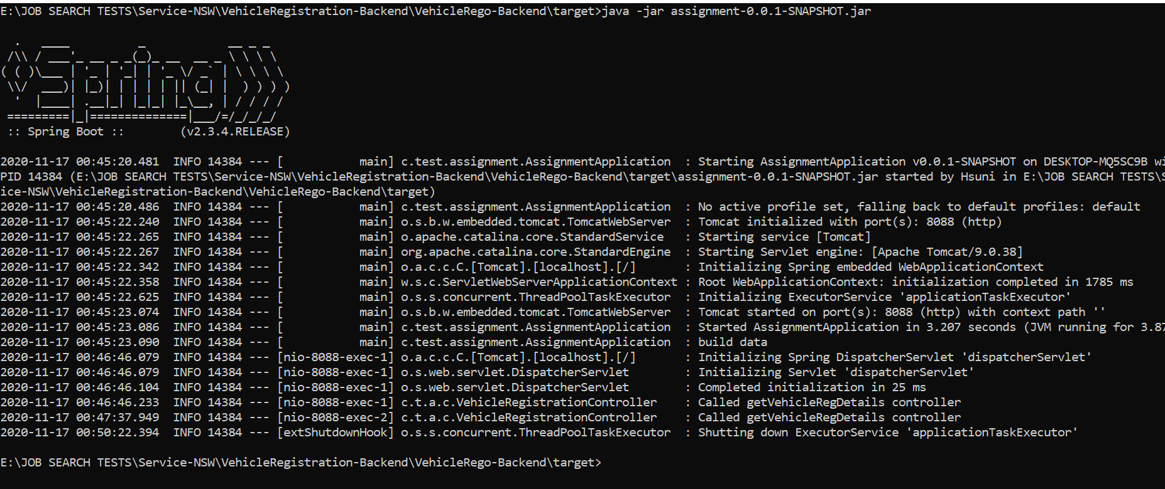

Front end UI:

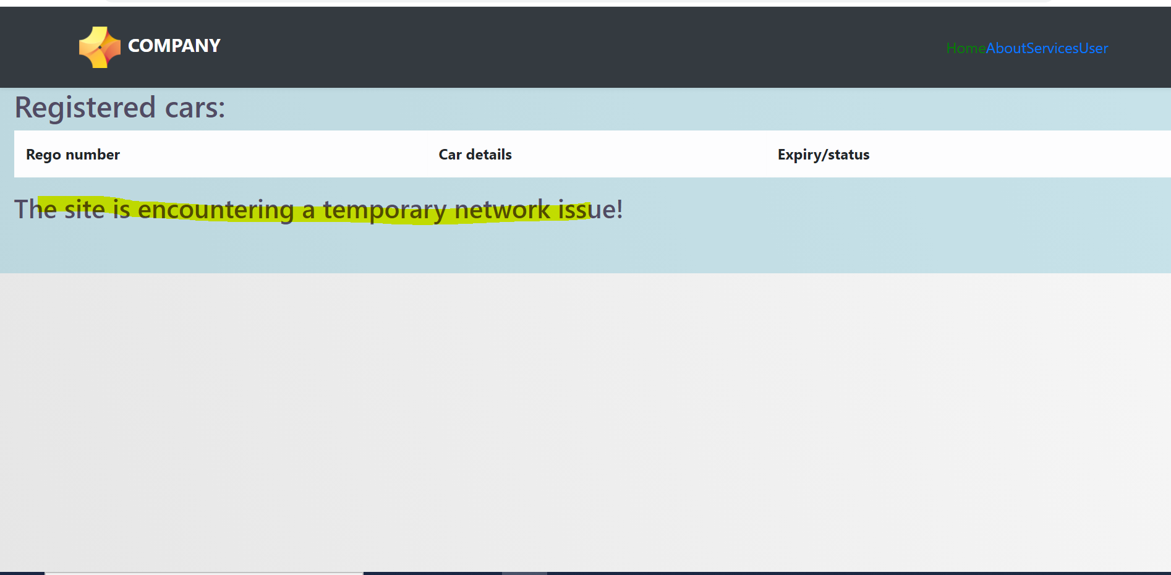

# Choice of the technology:

**Spring Boot:**

The main goal of Spring Boot Framework is to reduce Development, Unit Test and Integration Test time and to ease the development of Production ready web applications very easily compared to existing Spring Framework, which really takes more time. To provide some defaults to quick start new projects within no time.

**React JS**

This is an open-source JavaScript library that is used for building user interfaces specifically for single-page applications. It's used for handling the view layer for web and mobile apps. React also allows us to create reusable UI components. The main purpose of React is to be fast, scalable, and simple.